Roll No.: _ _ _ _ _ _ _ _ _ _ _ _ _ _ _ _ _ _ _

Amrita Vishwa Vidyapeetham

B.Tech. First Assessment – August 2019

First Semester

Common to all Engineering Departments

19CSE100 Problem Solving and Algorithmic Thinking

**Set-1**

Time: Two hours Maximum: 40 Marks

**Course Outcomes (COs):**

|  |  |
| --- | --- |
| **CO#** | **Course Outcomes** |
| CO1 | Apply algorithmic thinking to understand, define and solve problems |
| CO2 | Understand an algorithm by tracing its computational states, identifying bugs and correcting them |
| CO3 | Apply the basic programming constructs for problem solving |
| CO4 | Design and implement algorithm(s) for a given problem |

**Answer all questions**

**Part A (20 Marks)**

1. You come home and the desk lamp in your apartment stopped working (it worked in the morning when you left the apartment!!). Given below are various steps to troubleshoot. What do you think should be the right order in which the following steps should be carried out to effectively identify the source of the problem? Rewrite them in the right order. [5 Marks][CO1]
   1. Check if there is power in the room.
   2. Check if the light bulb is working
   3. Check if the outlet is working.
   4. Check if the lamp is turned on.
   5. Check if the lamp is plugged in.

**Solution:** The following is the sequence that helps one to effectively identify the source of the problem. [1 mark for each right position]

* 1. Check if the lamp is plugged in.
  2. Check if the lamp is turned on.
  3. Check if there is power in the room.
  4. Check if the outlet is working.
  5. Check if the light bulb is working.

1. The following flowchart models the generation of some numbers in a certain range. [5 Marks] [CO2]
   1. Write the first and the last three numbers it generates.
   2. Modify the given flowchart to generate the number sequence 1, 4, 9, 16, 25, 36, 49

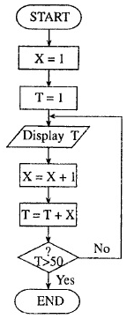

**Solution:**

* 1. First three numbers: 1, 3, 6 and Last three numbers: 28, 36, 45 [3 Marks]
  2. Change X = X+1 into X = X+2 [2 Marks]

1. What condition could lead the following flowchart to get stuck in an infinite loop? Explain your answer. [5 Marks][CO2]

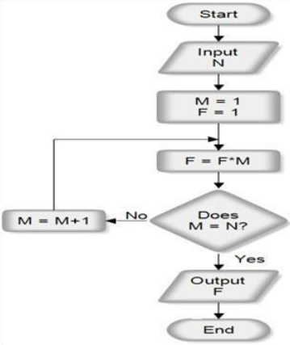

**Solution**: When N <= 0 the flowchart will get stuck in infinite loop. [2 Marks] A loop breaks when the condition given above becomes true i.e. when M == N. The given increment statement M = M + 1 ensures that the condition will eventually becomes true. However if N is a negative value the increasing M can never approach a negative value resulting in an infinite loop. [3 Marks]

1. Assume there are four boxes (labelled 1-4) available. Based on the values in first three boxes the following flowchart assigns letters in Box 4. Please read Is (2) < (1) as Is the value in Box 2 less than the value in Box 1. Now given that at the end of this process, Box 4 contains letter B, then answer the following questions. [5 Marks][CO1]
   1. Which of the boxes contain the largest number?
   2. Which of the boxes contain the smallest number?
   3. Explain your answer.

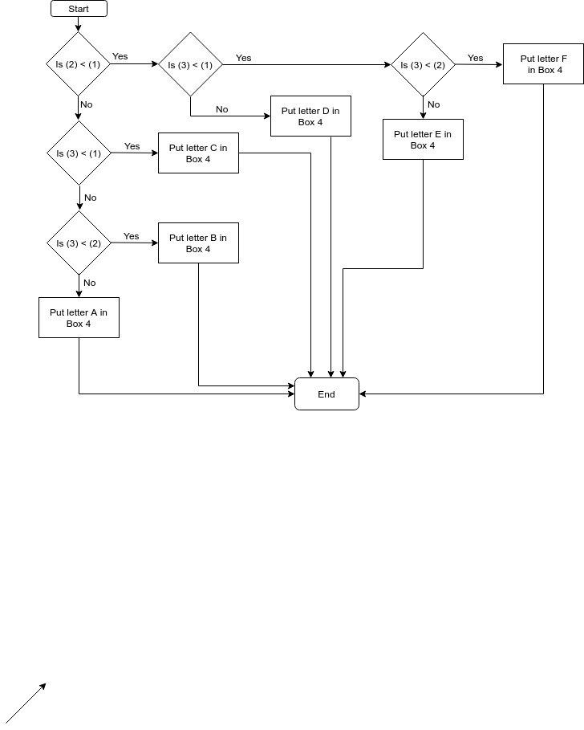

**Solution:** Box 2 contains the largest number [1 Mark] and Box 1 contains the smallest number [1 Mark]. Since the content of Box 4 is known if we trace bottom-up in the above flowchart we will get the satisfied and unsatisfied conditions which in turn gives clue about the relationship between values in Boxes 1, 2 and 3. [3 Marks]

**Part B (20 Marks)**

1. Write a flowgorithm to find the square root of a given number n*.* Find below an algorithm to compute the square root of a given number. [10 Marks][CO3]
   1. Make a guess at the answer i.e square root (typical value is guess = 1)
   2. Compute r = n/guess
   3. Set guess = (guess + r)/2
   4. Go back to step b) for as many iterations as necessary.

The more the steps b) and c) are repeated the closer the guess becomes the square root of n. How do you decide how many times the steps b) and c) should iterate? Can you make that decision part of your flowgorithm?

Once you have implemented the square root, cube root is a mere extension. Write a flowgorithm to implement the cube root of a given number n. Use guess = (n/guess2 + 2*guess)/3 to improve the guess.

1. A right triangle can have sides that are all integers. The set of three integer values (side1, side2 and hypotenuse) for the sides of a right triangle is called a *Pythagorean triple*. These three sides must satisfy the relationship that the sum of the squares of two of the sides (i.e. side1 and side2) is equal to the square of the hypotenuse. Write a program (use functions) that finds all Pythagorean triples for side1, side2, and the hypotenuse all no larger than 500. Find below the output your program is supposed to produce. [10 Marks]

[CO3]

Side1 Side2 Hypotenuse

3 4 5

5 12 13

6 8 10

7 24 25

8 15 17

9 12 15

...

300 315 435

319 360 481

320 336 464

325 360 485

340 357 493

(beyond this hypotenuse exceeds 500!!)